

**THE EQUI-FUN CLUB NEW MEMBER APPLICATION PACK**

**Do you want to compete, but don’t feel**

**ready for Riding or Pony Clubs??**

***You need the Equi-Fun Club!***

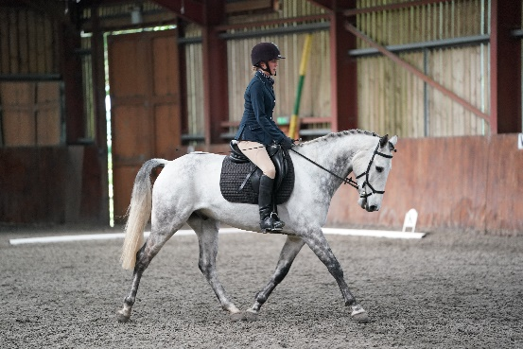

The Equi-Fun Club is aimed at any age or ability rider and also the whole family who ride and enjoy their horse/ponies for fun and for those who want to compete at a fun level!

We run shows and activities throughout the year at venues in the South East and our Members have exclusive entry, whereby they can enter via email or telephone, enjoy lesser entry fees, and have free entry vouchers to certain events. Our members are kept fully informed of all Equi-Fun events via email, website Facebook and a quarterly newsletter with all our news and results which are sent out via email.

Additionally the Equi-Fun Club have Public Liability Insurance in place for members at our events. We maintain a fun, but professional atmosphere for all to compete in, which includes experienced, qualified judges, trainers and assistants. We try to change the judges regularly to maintain impartial and non-repetitive judging.

Our events are organised so that everyone is included, relaxed and having fun, and there is an emphasis on everyone having a go and **enjoying** their horse/pony. If you are happy, then your horse will be happy too, and that makes for a confident partnership!

The club has grown significantly over the years and we hope it will continue to grow with the support of the members. 2021 looks truly exciting with lots of things planned.

For 2020 we introduced our Non Riding membership, which is for people who would like to support the club but either do not have a horse anymore or no longer wish to ride for shows or clinics.

**FAMILY MEMBERSHIP (2 Adults, 2 Children)**

**£45** for the first year, then £40 annually

**JOINT MEMBERSHIP (2 People)**

**£40** for the first year, then £35 annually

**INDIVIDUAL MEMBERSHIP (1 person)**

**£35** for the first year, then £30 annually

**NON RIDING MEMBERSHIP (1 person)**

**£10** annually

Membership benefits include:

* Reduced entry fees for Equi-Fun events
* Priority booking for Equi-Fun events
* Access to our Members Only Facebook group
* Members discounts with local businesses
* Receive the club newsletter

**Membership runs from February 1st to January 31st 2022**

Please fill in the attached application form and return to:

***The Membership Secretary, 36 Warningore Cottages, East Chiltington BN7 3AT***

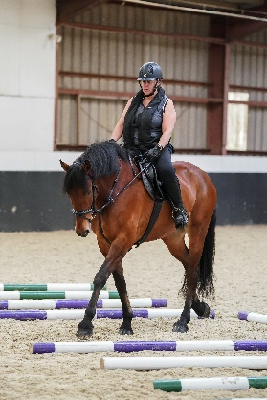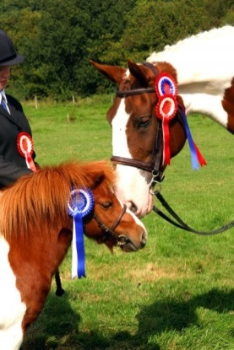

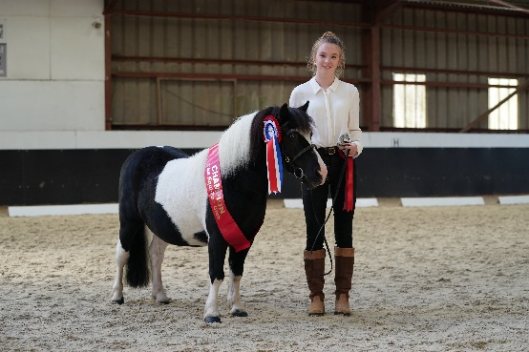

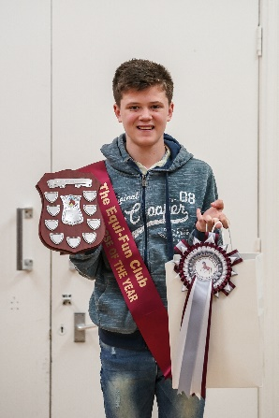

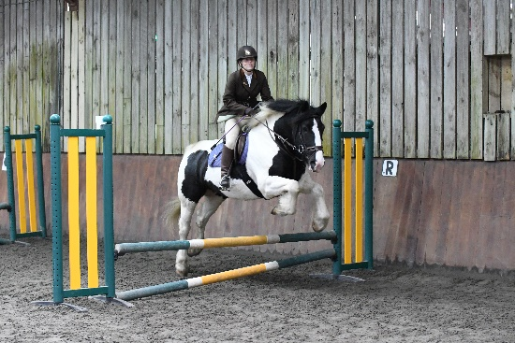

**Our Membership Secretary is Esmee Luckett**

**THE EQUI-FUN CLUB RULES & CONDTIONS**

***Please note any different or event specific rules relating to a particular event***

***will be noted under that schedule.***

**DRESS:** Everyone mounted, whether competing or not must wear a hard hat conforming to the following standards with a harness properly adjusted and fastened. Hats to specification PAS015(1998 or 2011). Hats to ASTM F1163(2004a) must have a SEI mark. Hats to SNELL E2001 must have an official SNELL label and number. Hats to AS/NZS 3838(2006) must have a SAI Global mark. No other hats will be allowed and skullcap hats must be worn with a silk.

**ENTRIES:** As club members you will get 48 hours PRIORITY BOOKING, which will be done via notification of the event on the Members Only Facebook Group. We will be using the Equo Events system for the majority of shows in 2020. Clinics, Talks and Social events can be booked via email, PM or Facebook comments with payment made by the due date (stated on all events). No verbal entries will be accepted. No entry fee will be returned without the production of a current veterinary certificate or doctor’s certificate. No entry will be accepted without the appropriate fee. Classes will be limited and in the event of over subscription, Equi-Fun members will be given priority. In the event of cancellation £2 will be retained to cover administration costs.

**ORGANISER’S RIGHTS:** The organisers reserve the right to alter, change, cancel and / or amalgamate classes or refuse entry without stating a reason. The judge’s / organiser’s decision is final. All competitors must abide by the steward’s instruction. Any persons riding or acting in a dangerous or inconsiderate manner or misusing whip or spurs may be asked to leave the showground and may be banned from future shows.

**RULES:** Classes will be run under the relevant equestrian body rules i.e. British Dressage/British Riding Clubs and the British Horse Society. In the case of BD these are available from the BD office at Stoneleigh, Warwickshire CV8 2LR

**DISCLAIMER OF LIABILITY:** Save for death and personal injury caused by the negligence of the owners or anyone for whom they are in law responsible, neither the organisers of the event to whom the rules apply nor the Equi-Fun Club nor any agent, employee or representative of the Club accept any liability for accident, damage, loss, illness or injury to horses, owners, riders, spectators or any other person or property whatsoever whether caused by their negligence, breach of contract, or in any way whatsoever.

**OBJECTIONS:** Must be made to the Secretary in writing within 30 minutes of the incident accompanied by a £10 deposit, returnable if the objection is sustained.

**HORSES, DOGS etc:** Dogs, bicycles, roller blades or similar are not permitted on the showground. Dogs must be confined to the owners vehicle. Horses / ponies must not be tied up outside boxes / trailers and left unattended. If any Horse / pony has been in contact with an infectious disease, it should not attend any shows, clinics etc. No lunging is allowed in the parking, competition or warmup arenas / areas. All horses attending events must be up to date with vaccinations.

**PARKING:** All drivers are asked to enter and leave the car park with due consideration for other users. Vehicles shall be parked in a neat and sensible manner in the car park. Droppings, hay and other rubbish is not to be left in the car park.

**HEALTH AND SAFETY POLICY:** The organiser has the overall responsibility for Health and Safety. The event is organised in accordance with H & S legislation and all who have (to any extent) control of premises or site at the event are responsible for ensuring that (a) everything reasonably practical is done to ensure the H & S and welfare of those attending the event (b) they conduct themselves so that they do not put themselves or anyone else at risk (c) access and egress to the site is safe. All competitors should comply with the rules of the venue

**VACCINATIONS:** All horses must be vaccinated to participate in club events. Horses must have had vaccinations within 6 months and 21 days of the competition to compete at Plumpton College and Chelwood Equestrian, all other venues are currently within 12 months. The vaccination rules may change so please always check with either the club or venue if unsure. Equi-Fun will do their best to keep you up to date via the club Facebook page.

**Your signature on the entry form shall be deemed to be acceptance of the Rules and Conditions shown here and throughout the schedule.**



**EQUI-FUN MEMBERSHIP APPLICATION FORM 2020**

Please fill this in and return with a cheque made payable to

‘Equi-Fun’ or by bank transfer (account number: 71430653, sort code: 40 15 16,

bank: HSBC), to the club address and your membership will be

processed as soon as possible…Thank you!

**MEMBER DETAILS**

|  |  |  |  |  |
| --- | --- | --- | --- | --- |
| **Membership Type**  (please tick appropriate box) | **Family (£45)** | **Joint (£40)** | **Individual (£35)** | **Non Riding (£10)** |

|  |  |  |  |  |  |  |
| --- | --- | --- | --- | --- | --- | --- |
| **Name of Member 1** | | |  | **Date of Birth** | |  |
| **Address** | | |  | | | |
|  | | | | | | |
|  | | **Postcode** | | |  | |
| **Tel No** |  | **Mobile no** | | |  | |
| **Email address** | | |  | | | |
| **Name of Member 2** | | |  | **Date of Birth** | |  |
| **Name of Member 3** | | |  | **Date of Birth** | |  |
| **Name of Member 4** | | |  | **Date of Birth** | |  |
| **ANY SPECIAL NEEDS OR OTHER REQUIREMENTS** (E.G. Disabities/Health issues or anything we should consider or allow at our events): | | | | | | |
| **INSURANCE DETAILS** (Insurance must be fully comprehensive and also include cover for the rider): | | | | | | |

**HORSE DETAILS**

|  |  |  |  |  |  |
| --- | --- | --- | --- | --- | --- |
| **Horse 1 Passport Name** |  | | | **Date of Birth** (Year is fine) |  |
| **Horse 1 Stable Name** |  | | | **Mare or Gelding** |  |
| **Breed** |  | **EX Racehorse** |  | **Colour** |  |

|  |  |  |  |  |  |
| --- | --- | --- | --- | --- | --- |
| **Horse 2 Passport Name** |  | | | **Date of Birth** (Year is fine) |  |
| **Horse 2 Stable Name** |  | | | **Mare or Gelding** |  |
| **Breed** |  | **EX Racehorse** |  | **Colour** |  |

|  |  |  |  |  |  |
| --- | --- | --- | --- | --- | --- |
| **Horse 3 Passport Name** |  | | | **Date of Birth** (Year is fine) |  |
| **Horse 3 Stable Name** |  | | | **Mare or Gelding** |  |
| **Breed** |  | **EX Racehorse** |  | **Colour** |  |

|  |  |  |  |  |  |
| --- | --- | --- | --- | --- | --- |
| **Horse 4 Passport Name** |  | | | **Date of Birth** (Year is fine) |  |
| **Horse 4 Stable Name** |  | | | **Mare or Gelding** |  |
| **Breed** |  | **EX Racehorse** |  | **Colour** |  |

**NOTE: All horses and ponies must be kept up to date with flu and tetanus vaccinations. You may be asked to provide a copy of this document for certain events.**

**We agree to abide by the rules and conditions of the Equi-Fun Club:**

**SIGNATURE:** _____**DATE:** _______

***MAY WE TAKE THIS OPPORTUNITY TO WELCOME YOU TO THE EQUI-FUN CLUB AND WE HOPE THAT YOU HAVE MANY HAPPY HOURS OF RIDING AND FUN WITH US!***